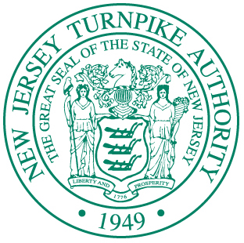
New Jersey Turnpike Authority
1 TURNPIKE PLAZA - P.O. BOX 5042 - WOODBRIDGE, NEW JERSEY 07095
TELEPHONE (732) 750-5300
DIANE GUTIERREZ-SCACCETTI, Chair
ULISES E. DIAZ, Vice Chair
MICHAEL R. DuPONT, Treasurer
RONALD GRAVINO, Commissioner
JOHN D. MINELLA, Commissioner
RAPHAEL SALERMO, Commissioner
FRANCISCO MALDONADO, Commissioner
JOHN M. KELLER, Executive Director
PHILIP D. MURPHY
GOVERNOR

SHEILA Y. OLIVER
LIEUTENANT GOVERNOR

VIA EMAIL April 5, 2023

RESPONSE TO INQUIRIES

REQUEST FOR BIDS
R-177600
BRUSH CHIPPERS

Below are the New Jersey Turnpike Authority’s responses to inquiries received with respect to the above-referenced Request for Bid (“RFB”).

Responses to Inquiries:

- Regarding the trailer connector specs, is there a typo regarding SAE code J506B, should it be J560B?

RESPONSE: Yes, per Section V; Specifications, CHASSIS. E, page 15 of the Request for Bids SAE code should be J560B.

- Are brake lights wired with turn signals or separate?

RESPONSE: Separate.

NO OTHER CHANGES. ALL OTHER DATA REMAINS IN EFFECT.

Very truly yours,

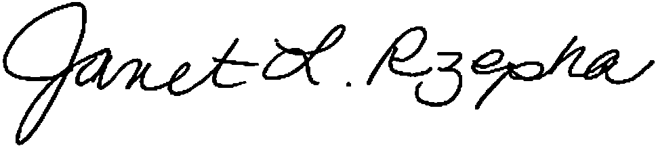
Janet L. Rzepka, Acting Director
PMM Department

Website address http://www.njta.com/

